A Course Project Report

on

**QUIZ GAME**

**Course:** Python Programming

Class: B.E CSE(AI&ML) Semester: II

By

**VAMSI KRISHNA DESINEEDI**

**1602-21-748-059**



**Department of Computer Science & Engineering**

**Vasavi College of Engineering (Autonomous)**

**Ibrahimbagh, Hyderabad-31**

**2022**

**INTRODUCTION-**

This is a complete error free quiz game mini project in PYTHON programming language. In this project there are total of 5 questions. The user is able to answer the next question only after answering the present question. The quiz is based on the programming language-PYTHON.

**LIST OF FEATURES-**

This Project provides quite a few features.

* Playing the Game
* Getting the Score
* Multi-repeat Game

**Description of Functions used-**

* **print() :** The print() function prints the specified message to the screen, or other standard output device.
* **input():** The input() function allows user input.
* **upper():** The upper() method returns a string where all characters are in upper case.
* **append()**: The append() method appends an element to the end of the list.
* **get():** The get() method returns the value of the item with the specified key.
* **new_game():** Auser definedfunction for new game.
* **checking_answer():** A user defined function for checking the answer**.**
* **show_score():** A user defined function for diplaying the sound.
* **play_again():** A user defined function for playing again.

**SOURCE CODE-**

#*******************MINI PROJECT ON QUIZ GAME IN PYTHON****************************

#***********developed by- VAMSI KRISHNA DESINEEDI(1602-21-748-059)*****************

# FUNCTION FOR NEW GAME

def new_game():

guesses = [];correct_guesses = 0;question_num = 1;

print("***********************Welcome to DVK QUIZ GAME*******************************")

for key in questions:

print("******************************************************************************")

print(key)

for i in options[question_num-1]:

print(i)

guess = input("Choose one option (A, B, C, or D): ")

guess = guess.upper()

guesses.append(guess)

correct_guesses += checking_answer(questions.get(key), guess)

question_num += 1

show_score(correct_guesses, guesses)

# FUNCTION FOR CHECCKING THE ANSWER

def checking_answer(answer, guess):

if answer == guess:

print(">>>>>>>>>>>>>>>>>>>>>>>>>>>>>>>CORRECT<<<<<<<<<<<<<<<<<<<<<<<<<<<<<<<<<<<<<<<<");print()

return 1

else:

print(">>>>>>>>>>>>>>>>>>>>>>>>>>>>>>>WRONG<<<<<<<<<<<<<<<<<<<<<<<<<<<<<<<<<<<<<<<<<<");print()

return 0

# FUNCTION FOR DISPLAYING THE SCORE

def show_score(correct_guesses, guesses):

print("******************************************************************************")

print("!!!!!!!!!!!!!!!!!!!!!!!!!!!!!!RESULTS!!!!!!!!!!!!!!!!!!!!!!!!!!!!!!!!!!!!!!!!!")

print("******************************************************************************")

print("Correct Answers: ", end="")

for i in questions:

print(questions.get(i), end=" ")

print()

print("Your Answers: ", end="")

for i in guesses:

print(i, end=" ")

print();print()

score = int((correct_guesses/len(questions))*100)

print("Your SCORE : "+str(score)+"%");print()

# FUNCTION FOR PALYING AGAIN

def play_again():

response = input("DO YOU WANT TO PLAY A NEW GAME? (YES or NO): ");print()

response = response.upper()

if response == "YES":

return True

else:

return False

questions = {"Which of the following concepts is not a part of Python?: ": "A",

"Which of the following statements are used in Exception Handling in Python?: ": "D",

"How is a code block indicated in Python?: ": "B",

"What is the maximum length of a Python identifier?: ": "D",

"Which of the following types of loops are not supported in Python?: ": "C"}

options = [["A. Pointers", "B. Loops", "C. Dictionaries", "D. All of the Above"],

["A. try", "B. except", "C. finally", "D. All of the Above "],

["A. Brackets", "B. Indentation", "C. Key", "D. None of the Above"],

["A. 32", "B. 16", "C. 128", "D. No fixed length is specified"],

["A. for", "B. while", "C. do-while", "D. None of the Above "]]

new_game()

while play_again():

new_game()

print("^^^^^^^^^^^^^^^^^^^^^^^^^^^^^COME BACK SOON^^^^^^^^^^^^^^^^^^^^^^^^^^^^^^^^^^^")

**TEST CASES-**

* This is the output screen the User gets when the user run’s the above Source code:

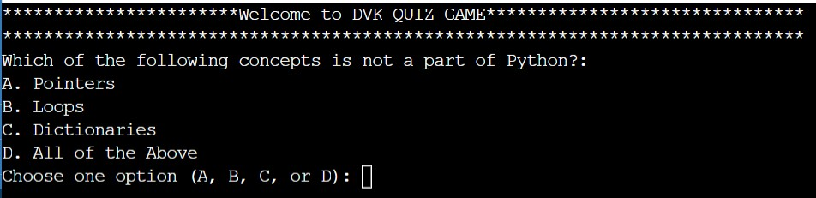

And now u can start answering the questions.

* After answering all the questions the user screen looks like:

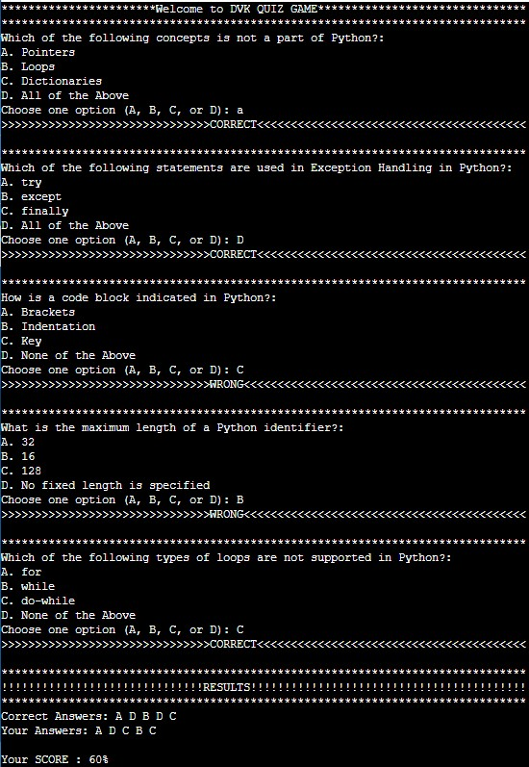

* After displaying the score, it asks a question to the user.

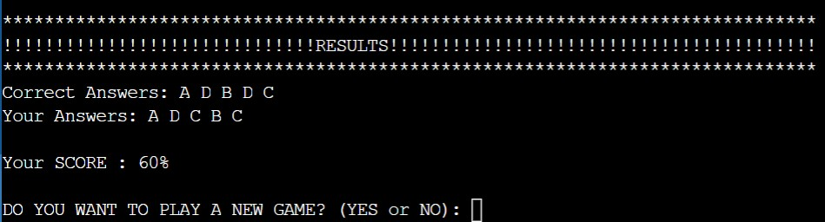

* If the User chooses the option “Yes”, It starts new fresh game.

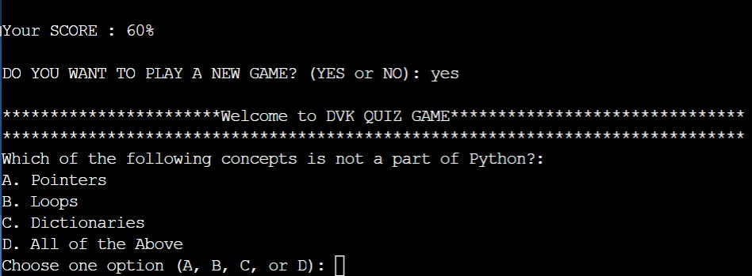

* If the User chooses the option “No”, it gives the user a message.

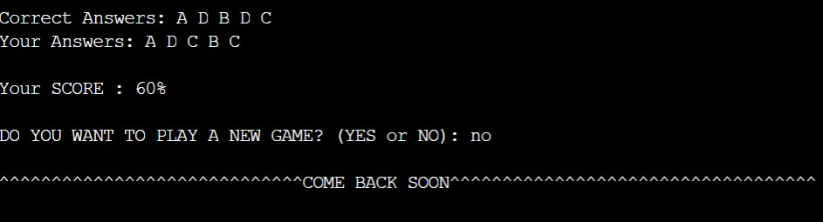

**------------------------------------------------------------------------------------------------------------------------------------------------------**

**CONCLUSION:**

I have understood how all the concepts in Python can be used in real life applications, even though it takes time to write Program it will be best option in going time. It reduces time in future and even Paper Work and data can be stored for long run and increases productivity and there is very less chances of mistakes happening. Through this project, I have learned the actual purpose of all the topics.

By implementing this project we learnt that creating quizzes using code can make it easier to conduct it than conducting quiz manually. It is easier to count the score. Finally we got to know how coding helps to create online quiz.

**FUTURE SCOPE:**

Even though there are better programs than this, used in real life. This Project is simple and clear that it would be easily habituated to the customers since it is very easy to understand. User’s Satisfaction and comfort is the first priority.

I t can be used to create many quizzes on different topics which helps people to improve their knowledge. It saves time and effort of people who used to conduct quiz manually.

------------------------------------------------------------------------------------------------------------------------------------------------